MINISTRY OF GENERAL EDUCATION
I/SCIENCE LESSON PLAN
NAME OF TEACHER:________________________ SCHOOL:_____________________
GRADE | TOPIC | SUB TOPIC | DURATION | DATE
8 | HUMAN BODY | Female Reproductive System | ____min | ____/___/__
ATTENDANCE: Boys:______ Girls:_______ Total:_____
TEACHING/ LEARNING AIDS : Chalk board, Learners books and Charts.
REFERENCES : I/Science Progress book 8
RATIONALE: This is lesson number two on the Human Body in the series of five. It will help learners acquire skills and values of identifying the parts of the human reproductive system. Group work, discussion, demonstration and Question & Answer methods will be used to execute the lesson.
PRE-REQUISITE SKILLS/ KNOWLEDGE: learners have prior knowledge on the Human body.
SPECIFIC OUTCOMES, LSBAT:
- Identify organs of the human reproductive system,
- Explain the functions of the parts of the Female reproductive system.
- Draw and label the Female reproductive systems.
STAGE | CONTENT | TEACHERS ACTIVITY | PUPILS ACTIVITY | METHODS
INTRODUCTION  ____min | Recap on the previous lesson.  HUMAN BODY  Male reproductive system.  (Male: testes, sperm duct, scrotum, urethra and penis | Teacher asks random questions | Pupils respond and participate | Brainstorm
D  E  V  E  L  O  P  M  E  N  T  ___min | HUMAN BODY  Female reproductive system (Side view).  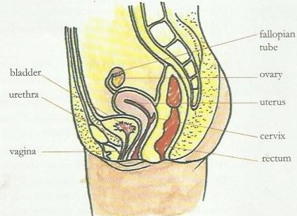  Front View  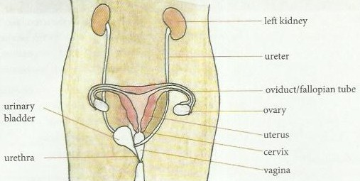  The functions of the parts of the reproductive system.  Females:  - Ovary - producing the ovules (eggs)  - Cervix - lower narrow end of the uterus where it joins the Vagina.  - Oviduct - where fertilization occurs  - Vagina - it accepts the penis during copulation and is the Birth canal for the feotus during normal child birth.  - Uterus- where the embryo develops during pregnancy. | Teacher explains the details to the learners  Teacher puts pupils in groups to discuss | Pupils listen and ask questions where not clear  Pupils discuss and bring out points  . | Teachers  Exposition  Group  work
 | Lesson Conclusion  Teacher emphasises on the main points of the lesson | Teacher asks random questions | Learners respond to the questions | Question  &  Answer
Exercise/ Activity/ Home Work
- Draw and label the female reproductive systems
- Explain the functions of any three parts of the female reproductive system.
PUPIL’S EVALUATION
………………………………………………………………………………………………………
TEACHER’S EVALUATION
………………………………..……………………………………………………………………

